Use decision trees to prepare a model on fraud data

treating those who have taxable_income <= 30000 as "Risky" and others are "Good"

library(C50)

library(caret)

library(gmodels)

library(dplyr)

##import the data in r##

Data <- read.csv(file.choose())

View(Data)

str(Data)

DataExplorer::plot_histogram(Data)

##there is no distributions in the variable

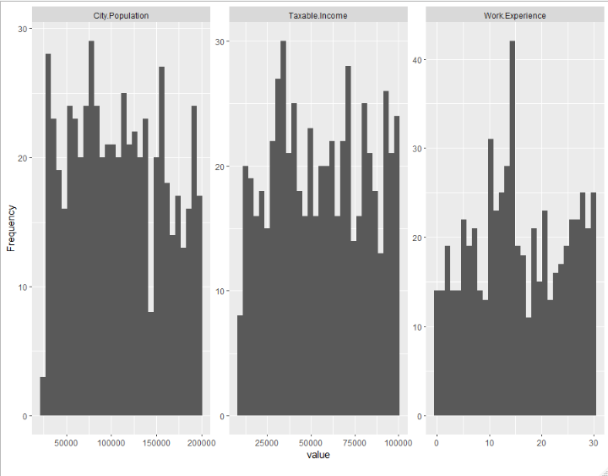

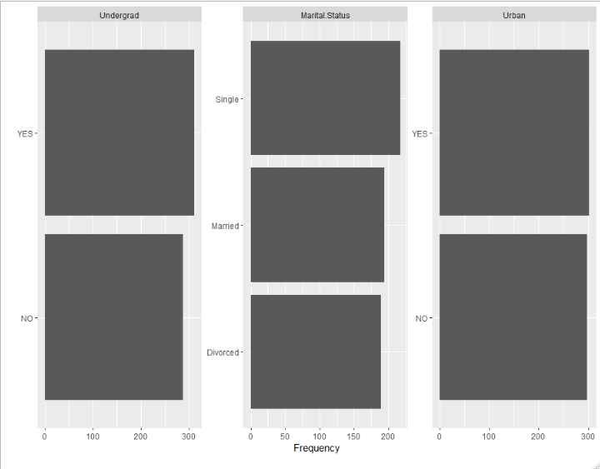

##The factor variable are evenly distributed

## making the taxable income to categorical variable##

Fraud<- if_else(Data$Taxable.Income<=30000,'Risky','Good')

Data <- data.frame(Data,Fraud)

##splitting the data into two##

set.seed(345)

train <- sample(1:600,450)

train_data <- Data[train,-3]

test_data <- Data[-train,-3]

##Model building ##

model <- C5.0(train_data[-6],train_data$Fraud)

model

plot(model)

##prediction of the model on the test data##

pre <- predict(model,test_data)

pre

##evaluation of the model##

mean(pre==test_data$Fraud)

confusionMatrix(pre,test_data$Fraud)##82.67accuracy

## in this model we have the values of good more then the risky so we have gone for over sampling technique

library(ROSE)

over <- ovun.sample(Fraud~.,data = Data,method = "over",N=952)$data

over$Fraud

(table(over$Fraud))

##splitting the data into two##

set.seed(345)

train1 <- sample(1:952,500)

train_data1 <- Data[train1,-3]

test_data1 <- Data[-train1,-3]

##Model building ##

model1 <- C5.0(train_data1[-6],train_data1$Fraud)

model1

plot(model1)

##prediction of the model on the test data##

pre1 <- predict(model1,test_data1)

pre1

##evaluation of the model##

mean(pre1==test_data1$Fraud)

confusionMatrix(pre1,test_data1$Fraud)##.79 accuracy

company Data

import pandas as pd

import numpy as np

import matplotlib.pyplot as plt

##importing the data set

data=pd.read_csv("Company_Data.csv")

data.info()## this function is used to known about the variable in the data set

data.head()

##To get the view of the data set

##in this data one float variable 7 int variable and 3 categorical variable are present

## we should covert the independent variable to numerical and dependent variable to categorical

data["US"].replace(['Yes','No'],[1,0],inplace=True)

data["Urban"].replace(['Yes','No'],[1,0],inplace=True)

data['ShelveLoc'].replace(['Bad','Medium','Good'],[0,1,2],inplace=True)

def sales_to_cat(x):

if x > 5:

return "High sales"

else :

return "low sales"

data["sales_categorical"]=data["Sales"].apply(sales_to_cat)

data["sales_categorical"].value_count()

##We will do some analysis on data set

data.describe()

data.mean()

data.var()

data.std()

data.skew()

data.kurt()

data.hist(figsize=(20,20))

data.corr()

##the main variable effecting the sales is the compprice

data.corrwith

## split the data set feauters and target variable

ind_var=['CompPrice','Income','Advertising','Population','Price','Age','Education','US','Urban','ShelveLoc']

x=data[ind_var]

y=data['sales_categorical']

from sklearn.model_selection import train_test_split # Import train_test_split function

X_train, X_test, y_train, y_test = train_test_split(x, y, test_size=0.3, random_state=1) # 70% training and 30% test

from sklearn.model_selection import train_test_split # Import train_test_split function

##model buiding##

from sklearn.tree import DecisionTreeClassifier # Import Decision Tree Classifier

from sklearn import metrics #Import scikit-learn metrics module for accuracy calculation

# Create Decision Tree classifer object

clf = DecisionTreeClassifier()

# Train Decision Tree Classifer

clf = clf.fit(X_train,y_train)

#Predict the response for test dataset

y_pred = clf.predict(X_test)

# Model Accuracy

metrics.accuracy_score(y_test, y_pred)

##0.708333

# Create Decision Tree classifer object##model 2

clf = DecisionTreeClassifier(criterion="entropy", max_depth=3)

# Train Decision Tree Classifer

clf = clf.fit(X_train,y_train)

#Predict the response for test dataset

y_pred = clf.predict(X_test)

# Model Accuracy, how often is the classifier correct?

metrics.accuracy_score(y_test, y_pred)

Accuracy: 0.825

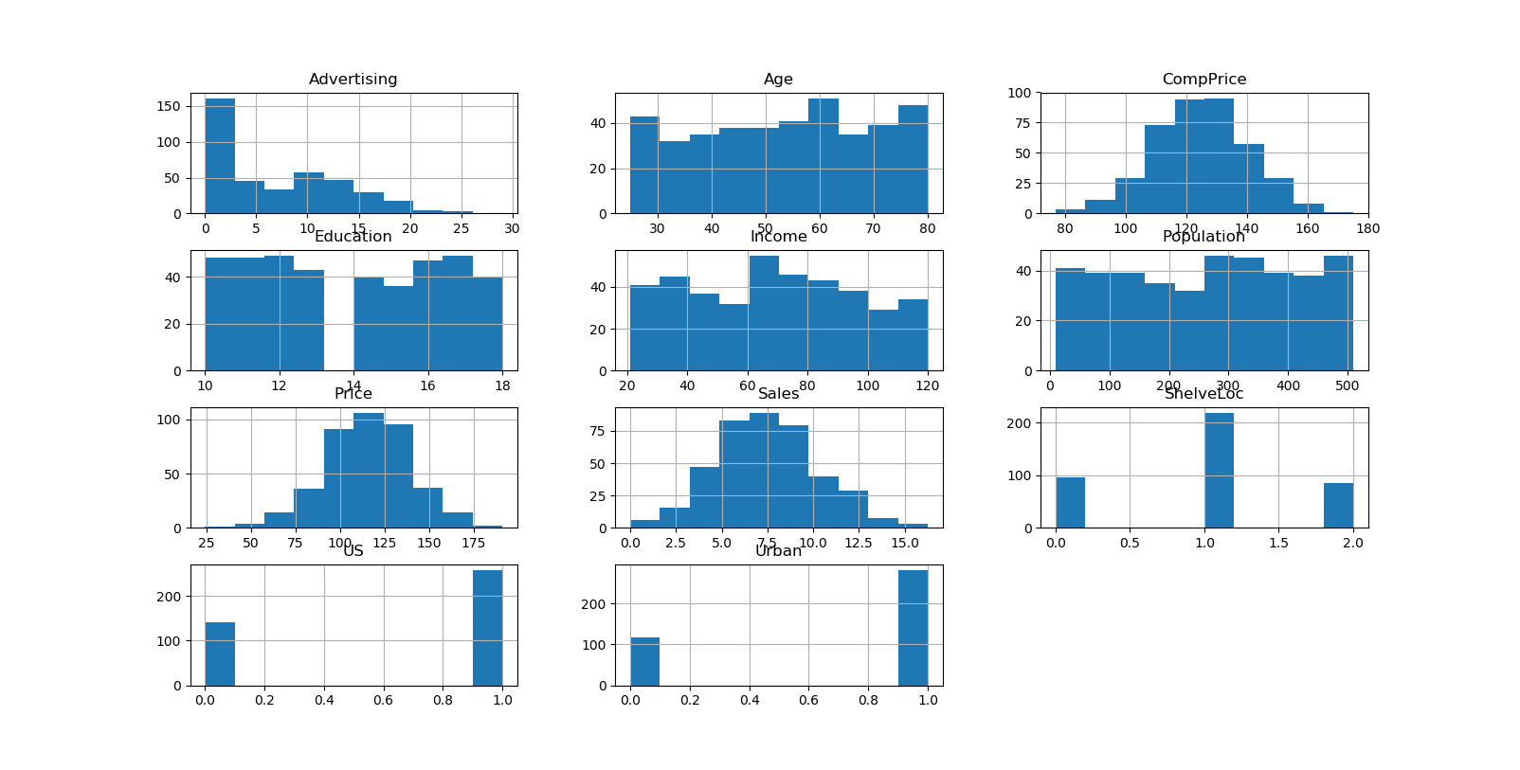

Iris data set

install.packages("C50") # we neeed to install C50 package to use ak

install.packages("tree")

library(C50)

data()

data("iris")

# Splitting data into training and testing. As the species are in order

# splitting the data based on species

iris_setosa<-iris[iris$Species=="setosa",] # 50

iris_versicolor <- iris[iris$Species=="versicolor",] # 50

iris_virginica <- iris[iris$Species=="virginica",] # 50

iris_train <- rbind(iris_setosa[1:25,],iris_versicolor[1:25,],iris_virginica[1:25,])

iris_test <- rbind(iris_setosa[26:50,],iris_versicolor[26:50,],iris_virginica[26:50,])

#### Using tree function

library(tree)

# Building a model on training data

iris_tree <- tree(Species~.,data=iris_train)

plot(iris_tree)

text(iris_tree,pretty = 0)

# Predicting the test data using the model

pred_tree <- as.data.frame(predict(iris_tree,newdata=iris_test))

pred_tree["final"] <- NULL

pred_test_df <- predict(iris_tree,newdata=iris_test)

# for (i in 1:nrow(pred_tree)){

# pred_tree[i,"final"]<-ifelse(pred_tree[i,"setosa"]>0.5,"setosa",ifelse(pred_tree[i,"versicolor"]>0.5,"versicolor","virginica"))

# }

pred_tree$final <- colnames(pred_test_df)[apply(pred_test_df,1,which.max)]

mean(pred_tree$final==iris_test$Species) # Accuracy = 94.66%

CrossTable(iris_test$Species,pred_tree$final)